**My WebAPI Docs**

**WebAPI Security (JWT Token based authentication) with Swagger**

1. Create a ASP.net WEbAPI Project
2. Add a Controller “LoginController”
3. Add References
   1. Microsoft.AspNetCore.Authentication.JwtBearer
   2. Microsoft.IdentityModel.Tokens
   3. System.IdentityModel.Tokens.Jwt
   4. Swashbuckle.AspnetCore

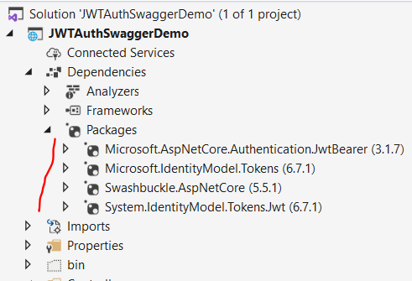

1. Modify te appsettings.json file and include the Key and Issuer

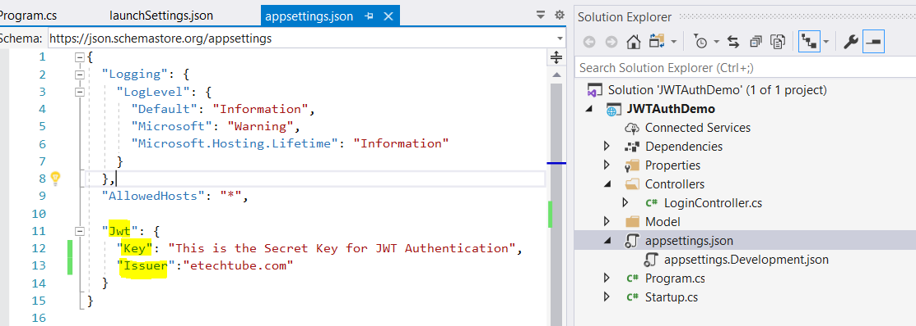

1. Open the Startup.cs file and modify as following
   1. Add Authentication

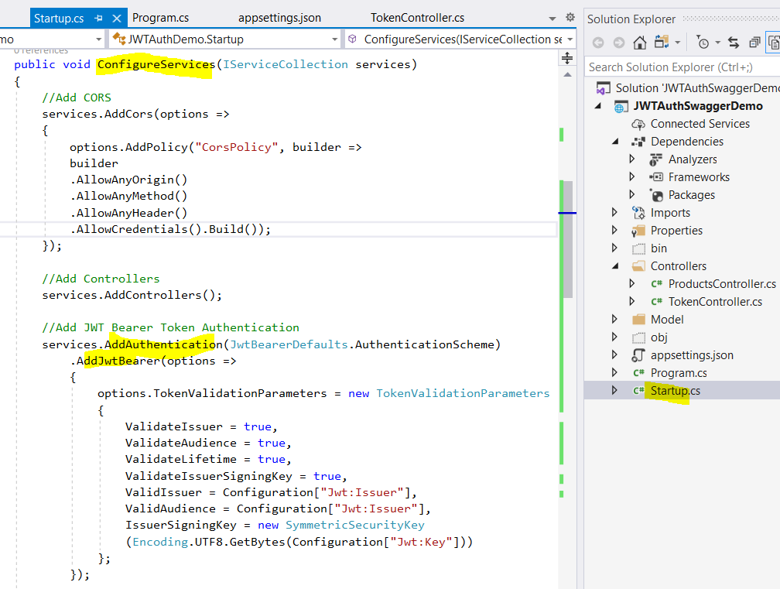

1. Add support for Swagger with Oauth

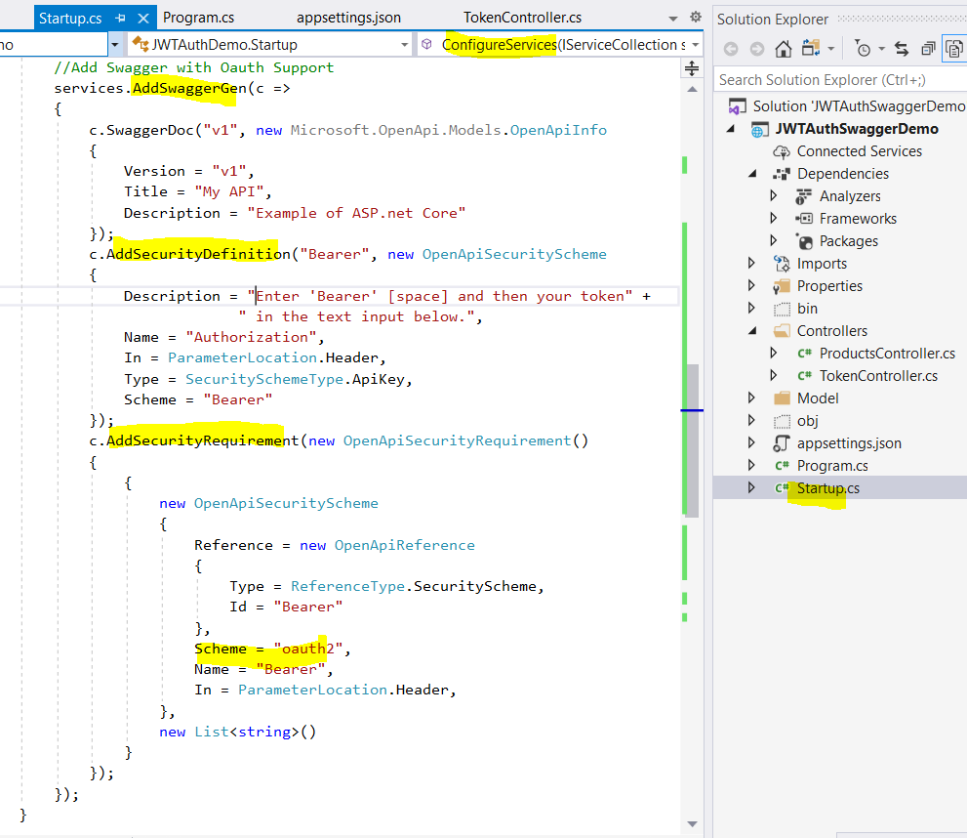

1. Also modify the Configure method and add Authentication block

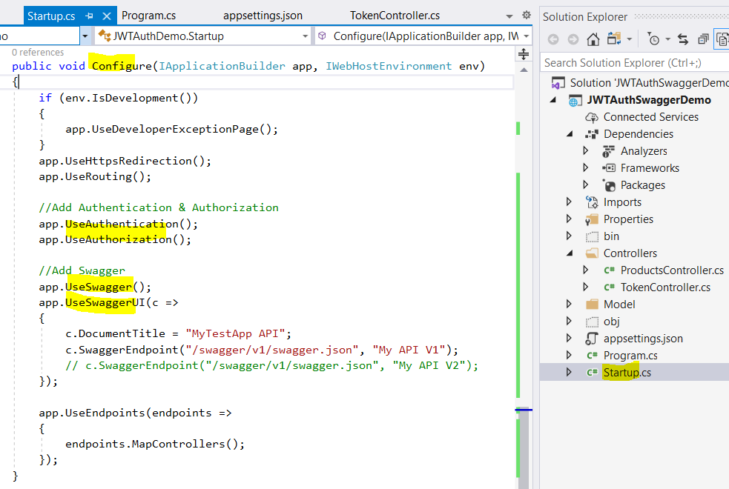

1. Create a new TokenController class derived from APIController

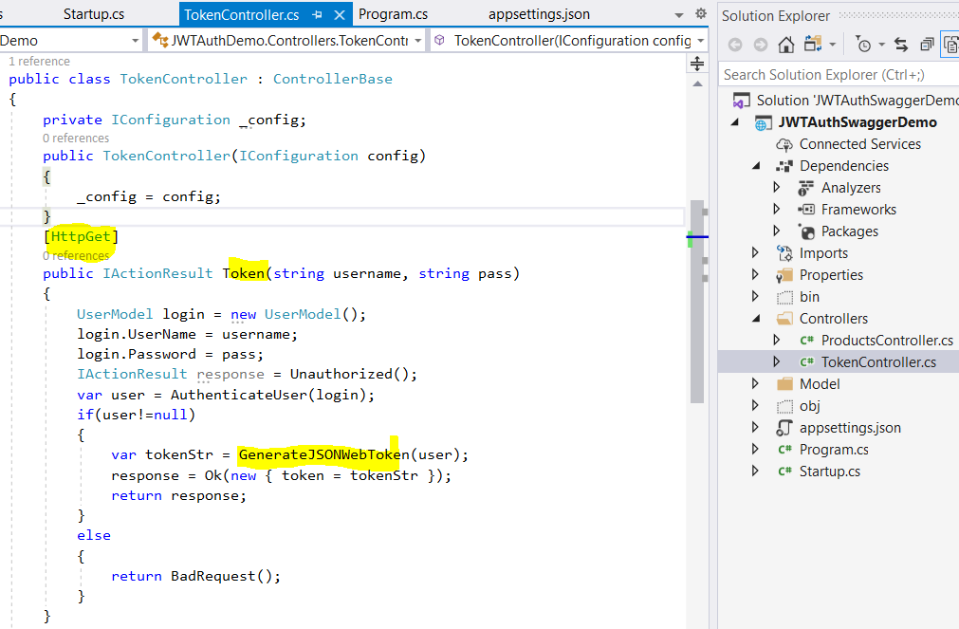

1. Add Token generation and user authenticator methods

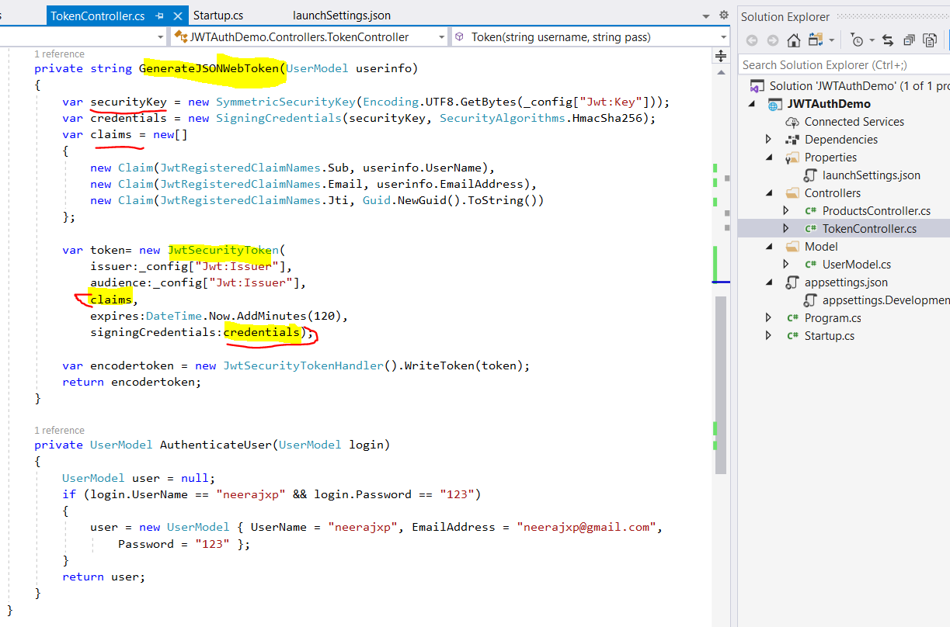

1. Now add authorization in WebAPIs to be secured

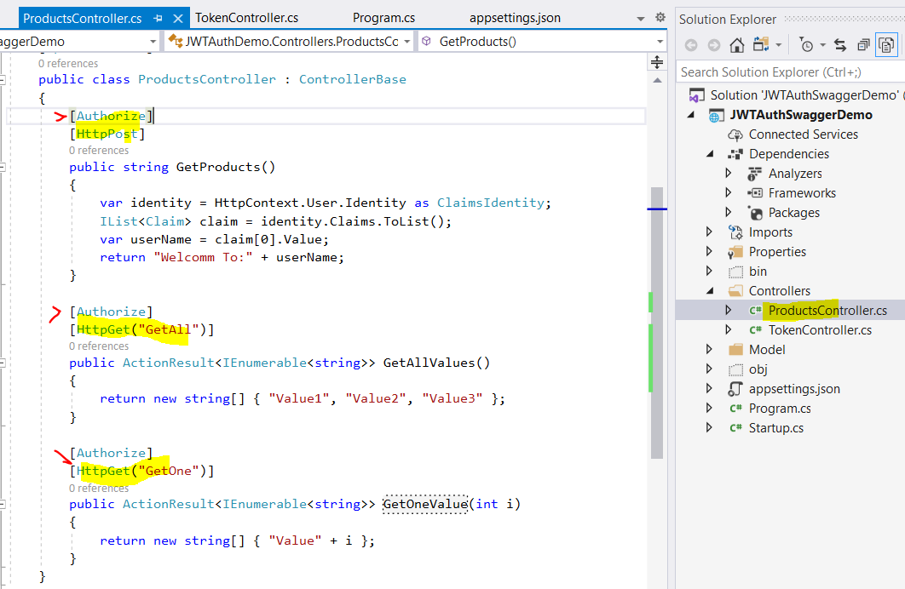

**Testing with Postman**

1. To test this. First run the token controller and get the token

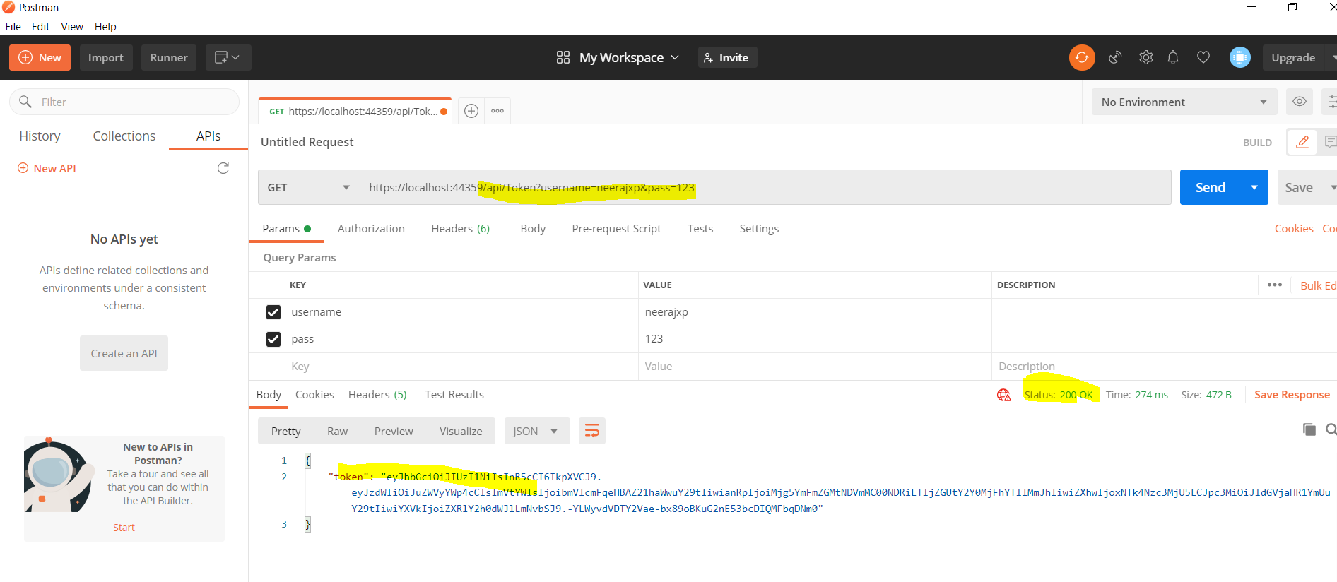

1. Then run the WebApi which you want to access with the bearer token. This should return 200 response

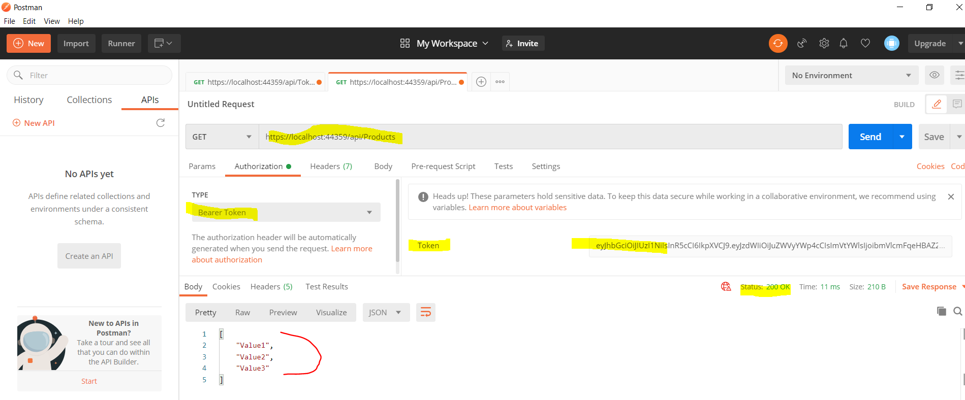

Testing with Swagger

1. Run the project and change the url to have swagger after server and port

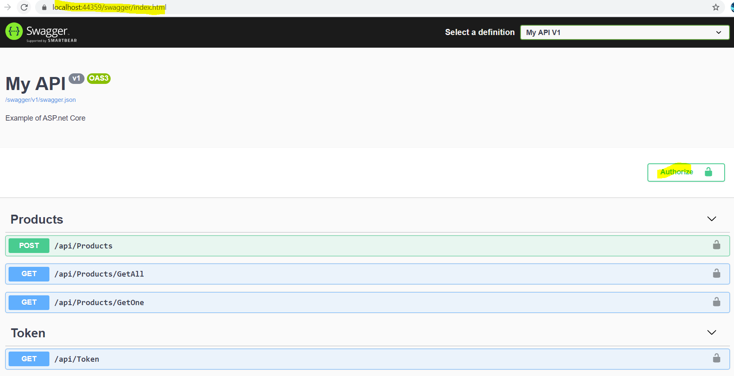

1. Hit the Token WebAPI first by entering username and password. Copy the token generated

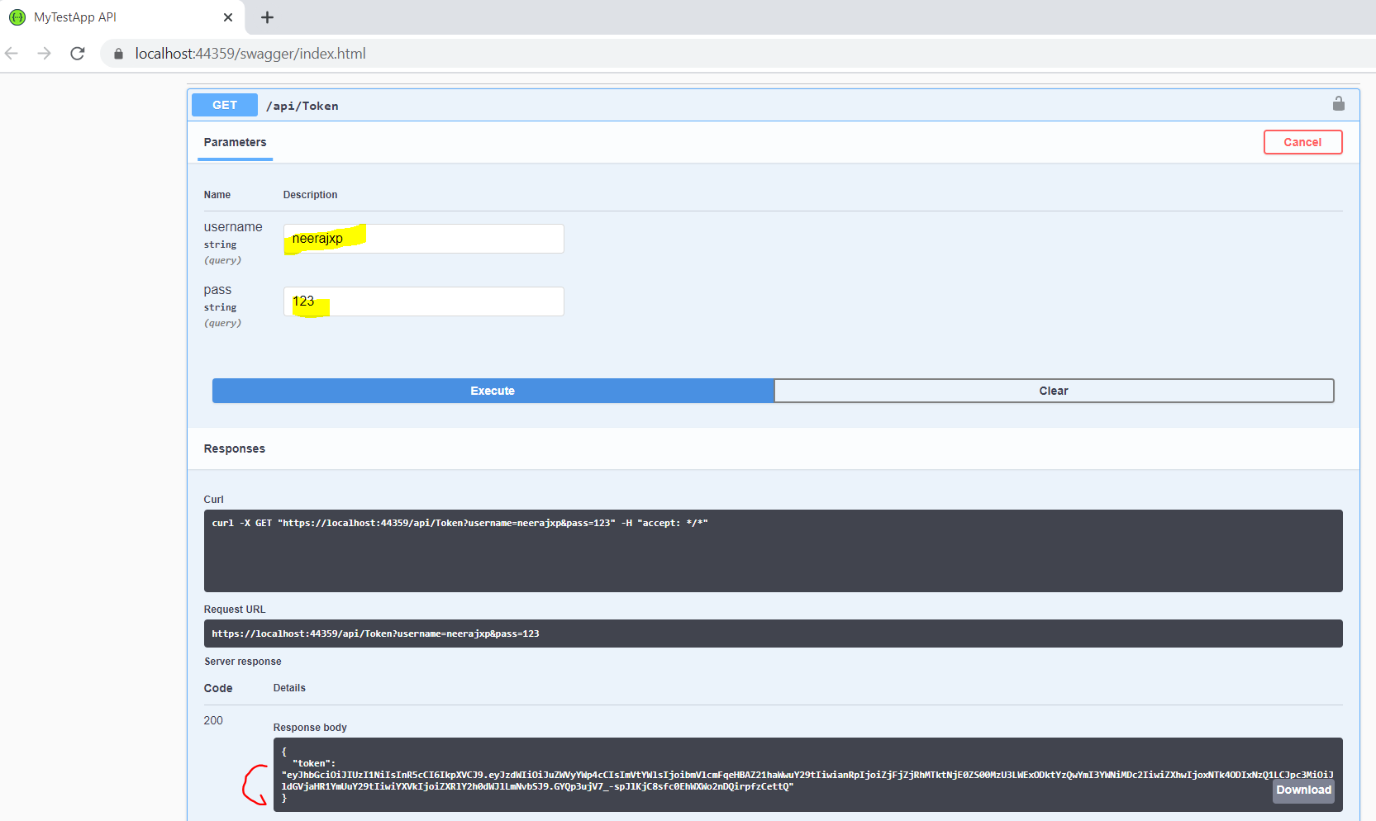

1. Hit the Authorize button and apply the Token, Prefix it with Bearer and hit apply

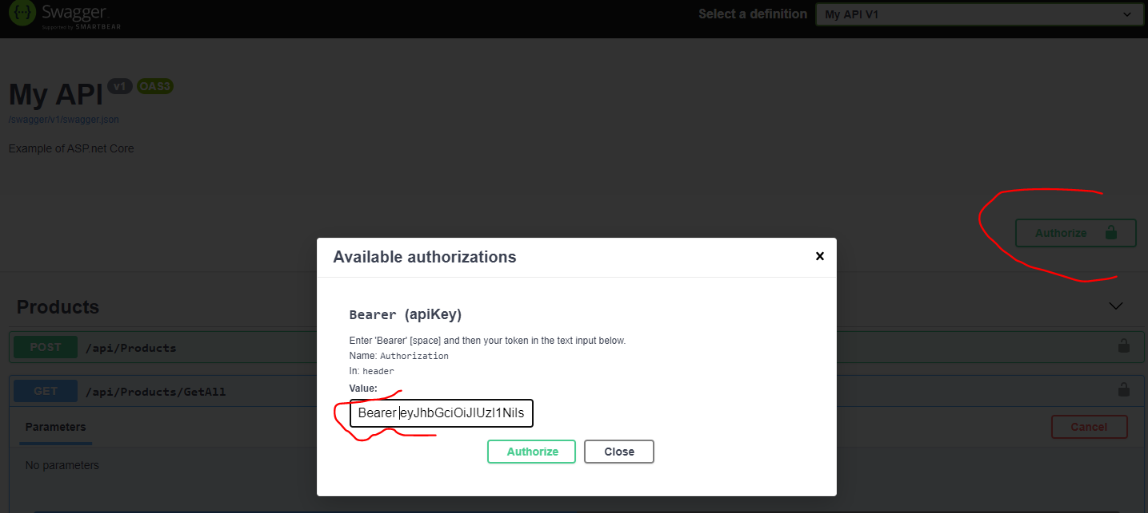

1. Now test the Product API

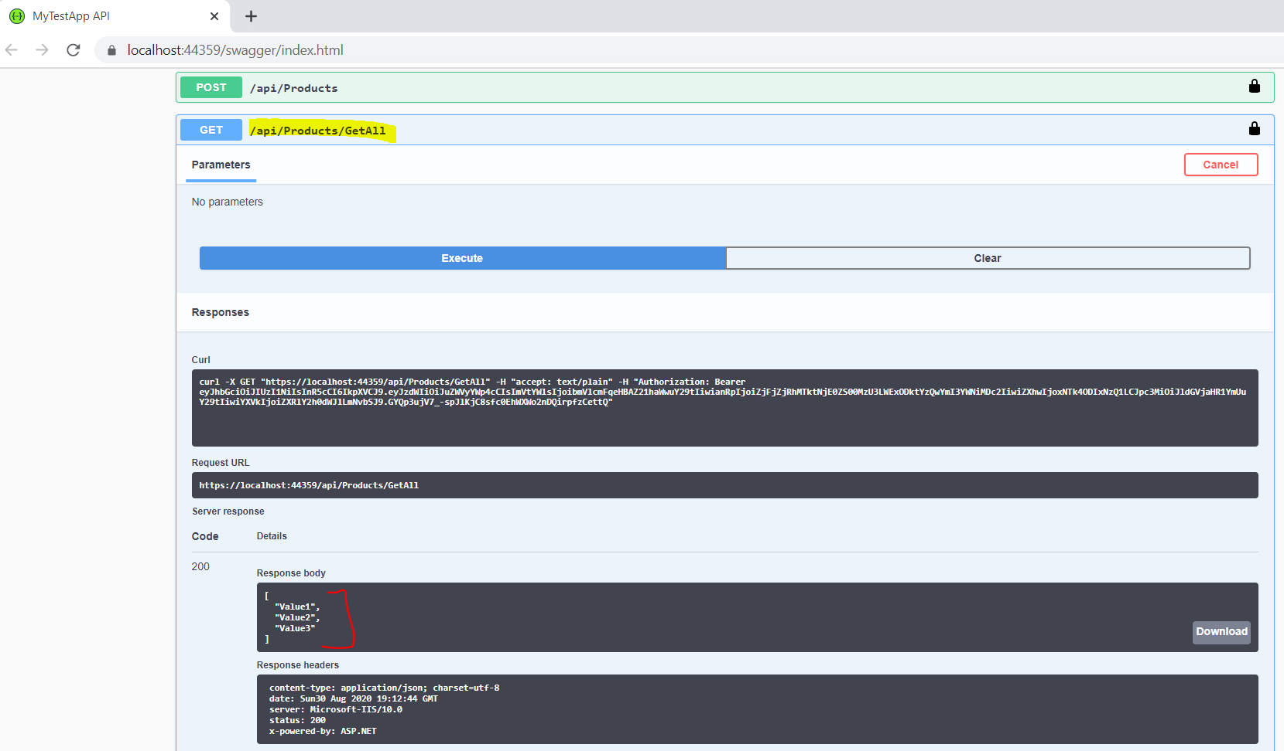

We see that the values are publishing. If we do a logout then we don’t see the right result. It will throw 401 (Unauthorized) exception

